**Assignment – 2**

1. Create a txt file called sales.
2. Load it into Pig.

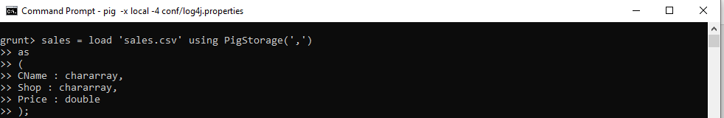

1. Describe the schema.

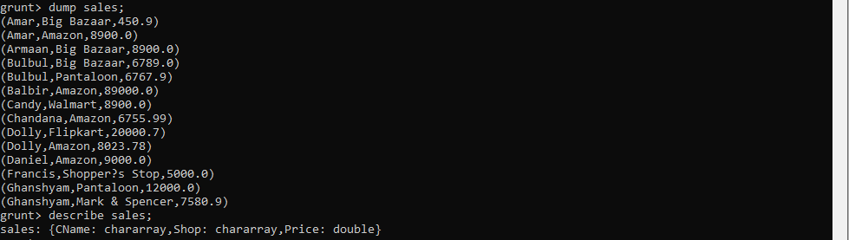

1. List total sales per department stores.

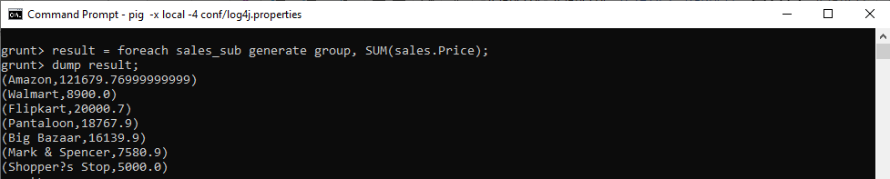

1. List total sales per customer.

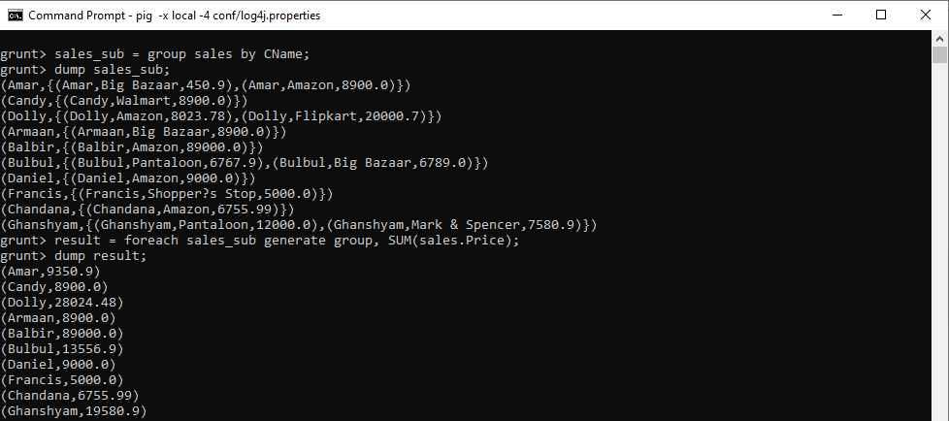

1. Create a txt file called emp.txt that contains Emp_No, EName, Job, Mgr_id, Hiredate, Sal, Commision, Dept_no .
2. Create a txt file called dept.txt that contains, Dept_no, Departmentname, Area .
3. Load the data into Pig.

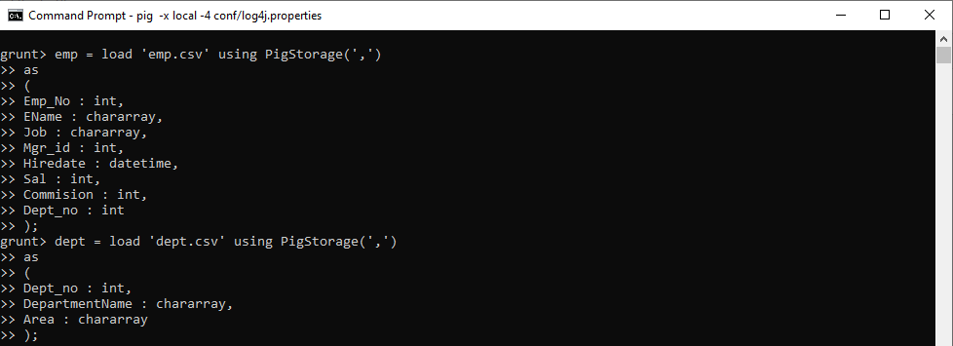

1. List Emp_No, Ename, Jon, Hiredate, Experience of all Managers.

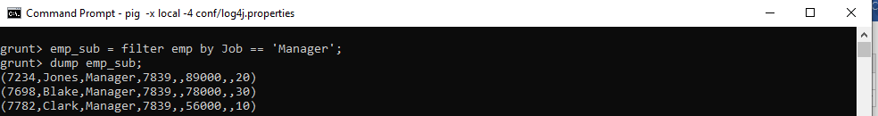

1. List all employee records in asc order of dept nbr. and desc of job title .

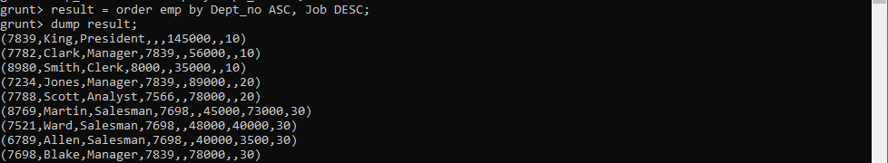

1. List details of employees whose commission is more than the salary.

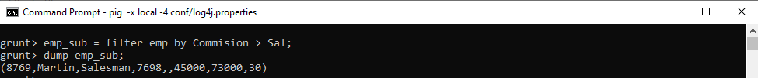

1. List details of employees whose commission is NULL.

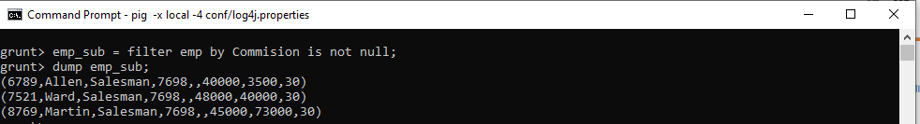

1. List all employee names that start with ‘S’ and end with ‘H’.

